[Java, OOP & Android tutorials for beginners in Bengali](https://www.youtube.com/watch?v=XjwTPNKs6Tc&list=PLV3rqOvr9vgkmELwlSouvJtROQ6MWRbIH)

[Zulkarnine Mahmud](https://www.youtube.com/user/zulkarnine2076) (tutorial-1)  
<https://www.youtube.com/watch?v=XjwTPNKs6Tc&list=PLV3rqOvr9vgkmELwlSouvJtROQ6MWRbIH>

*Java: programming language (jar bebohar sob khane- website/android phn/android game/bivinno dhoroner application)

*java sikhar aage c,c++ janle subidha

*javar onk boro ekta library ache, ebong object oriented programming(OOP) er karone eta eto ta use ful

* computer 0 & 1 chara kichu bujhe na

* computer k Jodi 0 r 1 dye bujhate chai je amr screen er kono ekta ongshe x,y coordinate e ekta picture dorkar, taile x,y er coordinate ta kono ekta function er moddhe dye dile,ebong sekhane kon pic ta dite chai seta diye dile,computer auto bujhe nye se jaigai sei pic ta display kore dbe

*emon onk function & library android, javar jonno create kora ache

1st class:

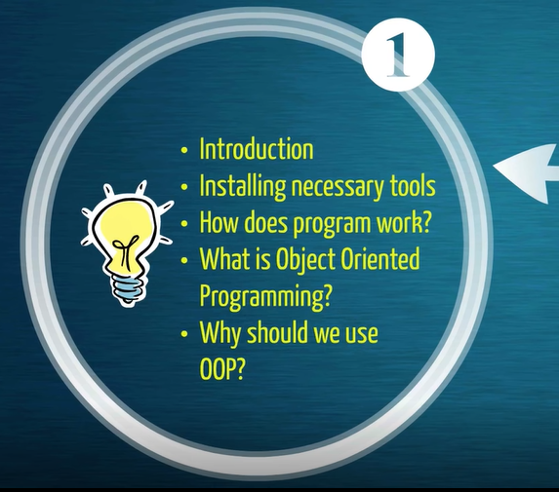

2nd class:

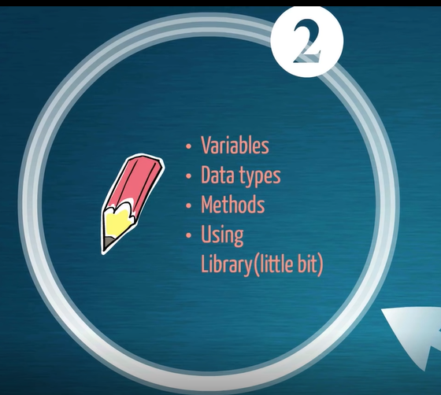

third class:

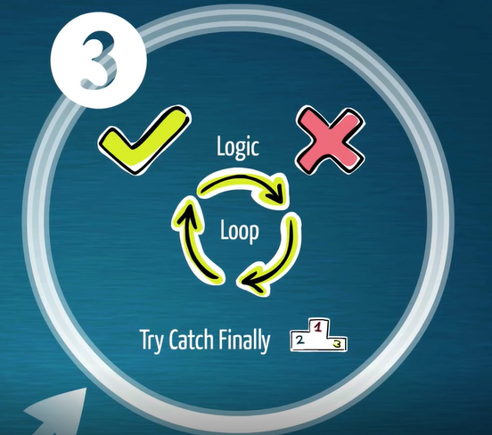

*logic- ekti gotona thik ki vul, 0 ki1 etar upor depend kore kono ekta action nite hobe

*loop: kono ekta condition full fill houya porjonto or na houya porjonto repeat kortei thakbe

*javar sobcheye important bisoy:

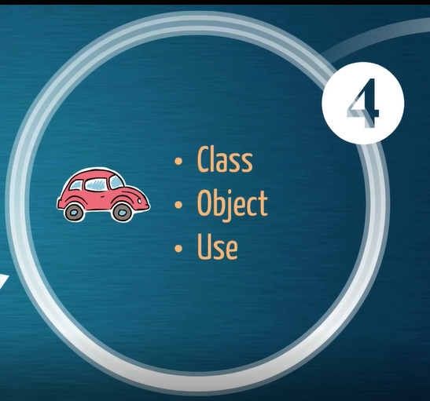

*object er karonei object oriented programming bola hoy

*Object er bangla bostu  
*jekono bostu k bojhate chaile setar kichu properties thake, r se jinista ki dhoroner kaj korte pare se dhoroner kichu bepar thake  
* jemon ekta manush, tar chuler color kalo, tar height koto khani, tar weight koto egula holo tar properties  
eder k bole intensive property  
* ektamanush hat-te pare khete pare,gan gaine pare, eta holo tar function or method.  
* ei jinish gulo ke ekotrito korar chesta k class bole  
*ekotre kono ekta properties o dye dte pari, kono ekta object e  
*esob kichur ekotrito somonnoye gothito library or javar je package gulo dey ache ogula kivabe efficeient vabe use korte pari:  






Today’s topic:  
  
  
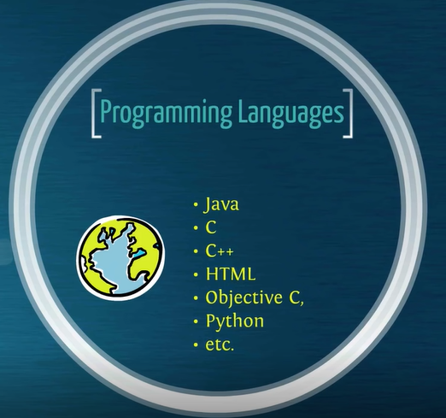  
  
*java- object oriented language, ei property tarkaronei java khub e jonopriyo & important, kono bostu(object) k somonnito koroar jonno bivinno function & properties er somonnnoye class gothon korte pari, ja pore valo vabe use kora jabe….er jonnoi java khub use ful

*c te class na thakar karone java use hoy…jodio c machine er khub kachakachi interpret korte pare command gulo k  
*esob multipurpous bivinno object er karone java k besi use kora hoy  
*kono kichu k represent korte gele object bananor proyojon pore, tokhn already library te thakle use kora, or nije baniye use korte pari, se jonnoi java amdr kache besi proyojonoi

Java runtime environment:  
  
pc te aagekhuje nibo control panel e JRE ache kina, nathakle setup deya lagbe

<https://www.java.com/en/>  


* Ekhan theke free java download e click korbo
* Tutorial e eclipse use hoise ,ami netbeans korbo
* Computer ti koto bit era age seta properties e gye jene nibo
* Ami netbeans namaye nibo
* Netbeans set up dibo (na parle tutorial dekho)
* Net beans e gye new project khulbo

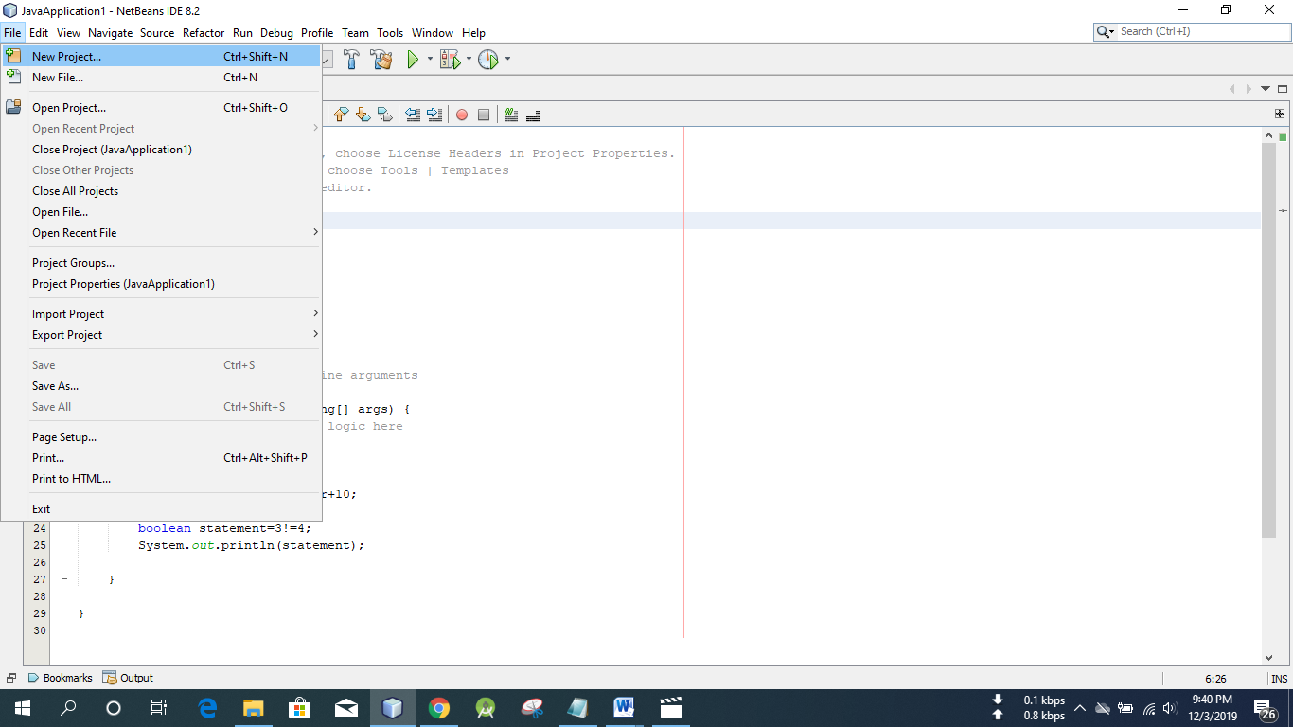

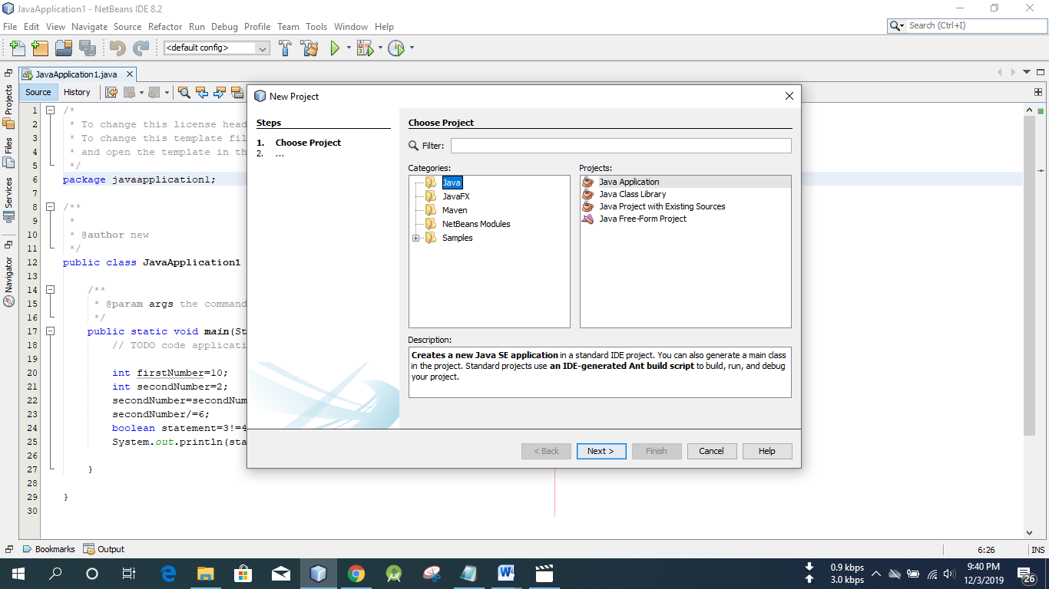

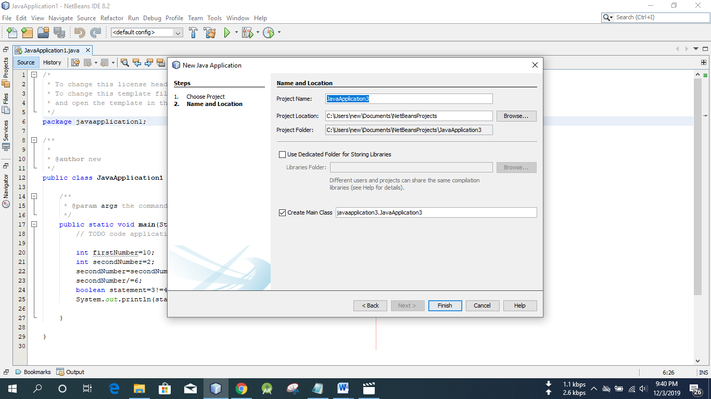

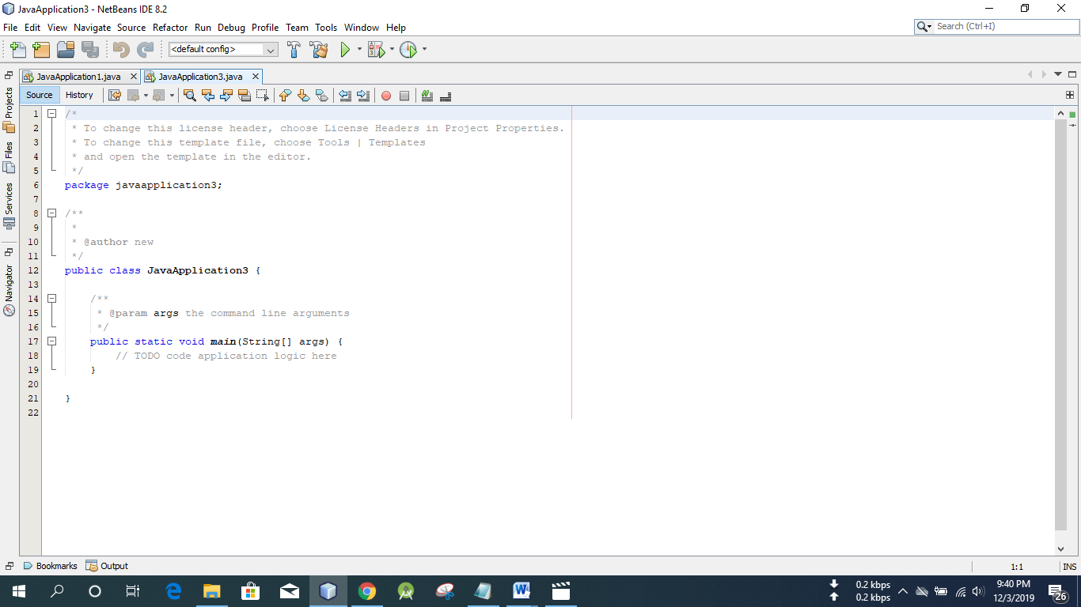

* Class k jokhon run kora hoy, khuje ber kore min kothai ache

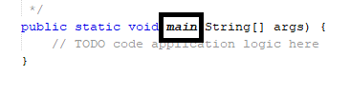  
*computeramdr hello bolbe, emon ekta project create korte chai

*java case sensitive, capital small thik kore lekha lagbe

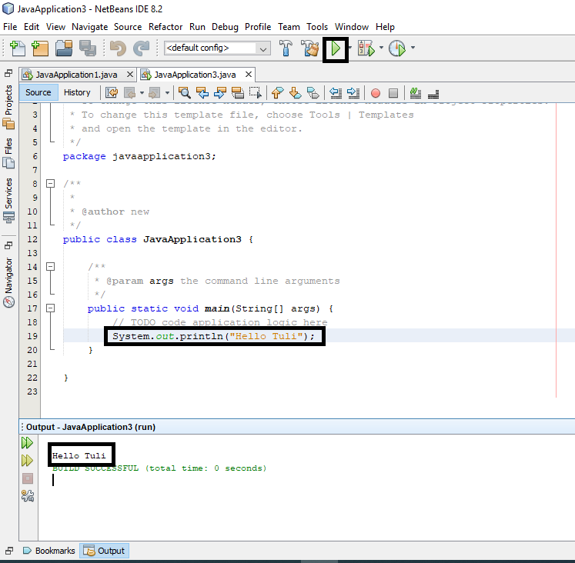

* chai je user je nam ta dibe sei nam ta print korbe:

* Scanner nam er ekta class banano ache
* Alter enter chepe scanner class ta k import kore nibo
* Scanner ekta object jeta screen k scan kore
* Sc nam er ekta object create korbo
* System.in mane system er input ta k scan korbe, ebong eta k 0 r 1 e convert kore bujhai dbe je ei jinish ta k scan korsi

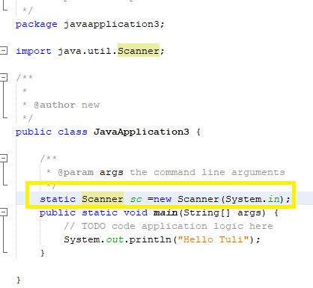

Scanner ta ekhon input nibe:

* Sentence save kora jai emon jinish k string bole
* Math e jemon x,y dhore nitam, string er khetreo name nam er object dhore nibo jekhane rakhbo sc.next line();   
  mane erpor theke next line e screen e je nam ta pabe se seta k name nam er variable e save kore nibe

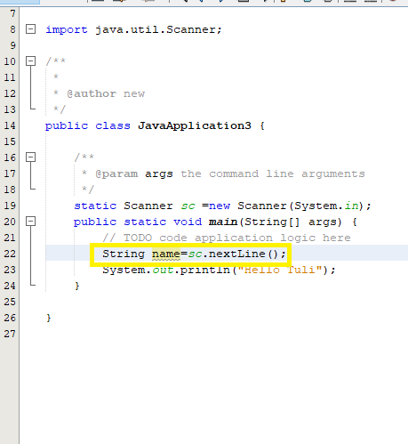

* + dile java automatic ekta sentence er por r ekta sentence ashle seta add kore dey
* (“hello!+name); name er modddhe user je naam dibe setai niye nibe

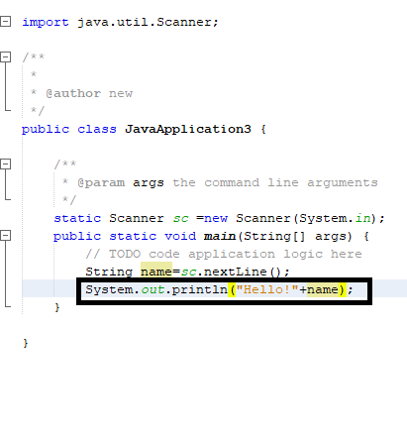

* User kmne bujhbe je ekhane amk nam deya lagbe?
* Println mane print notun line

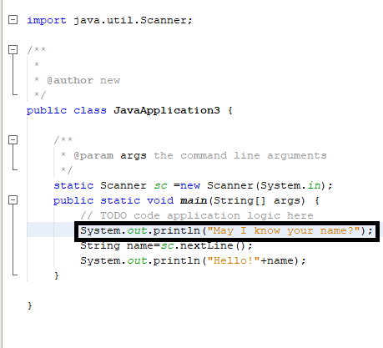

* Ekta line gap dite \n use hoy

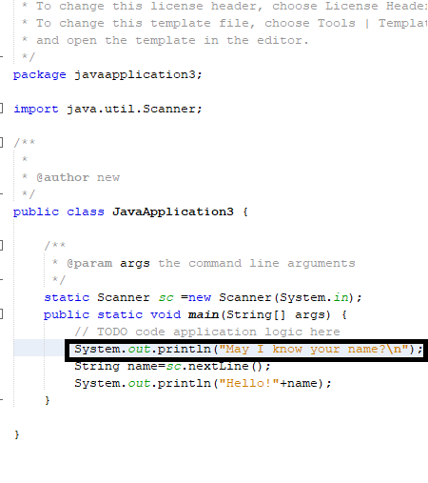  
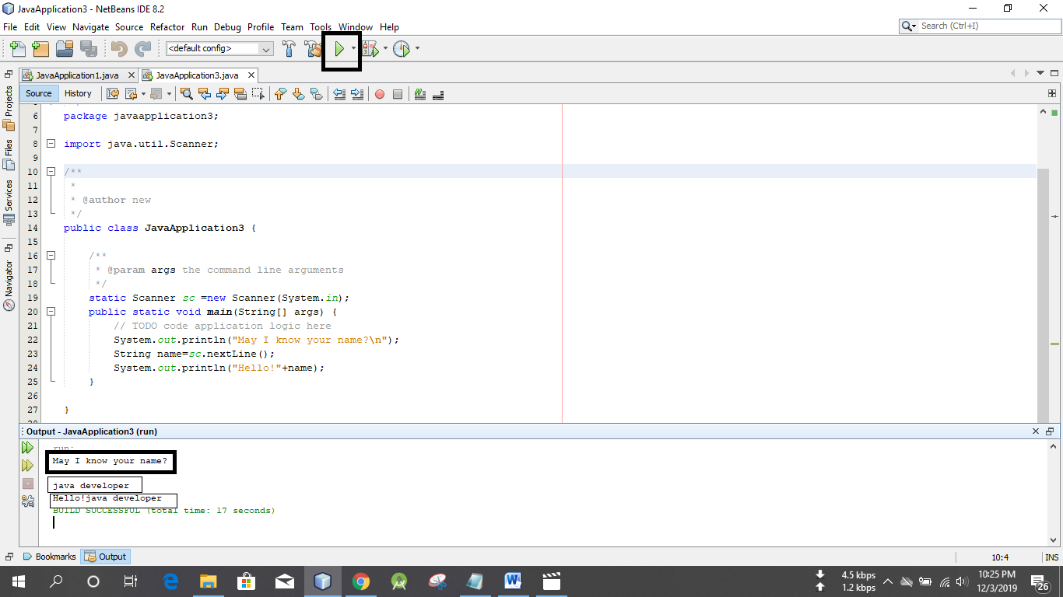

[Java, OOP & Android tutorials for beginners in Bengali](https://www.youtube.com/watch?v=XjwTPNKs6Tc&list=PLV3rqOvr9vgkmELwlSouvJtROQ6MWRbIH)

[Zulkarnine Mahmud](https://www.youtube.com/user/zulkarnine2076) (tutorial-2)  
<https://www.youtube.com/watch?v=Ywxg4Hxa2jA&list=PLV3rqOvr9vgkmELwlSouvJtROQ6MWRbIH&index=2>

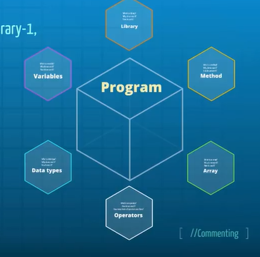

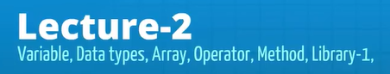

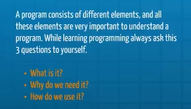  
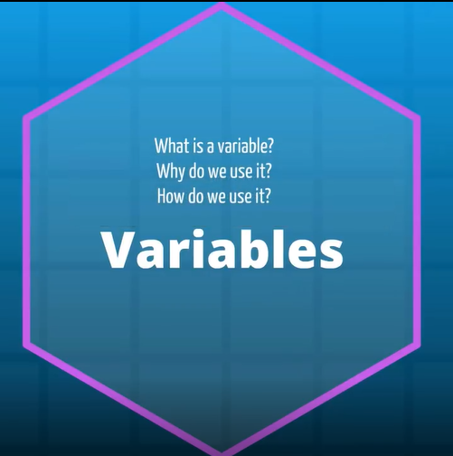

* X,y egula k bole variable, era specific kichu datar substitute hisebe kaj kore
* Jar jaigai onno kichu bosale equation ta solve hoye jabe

Vriable er data type:

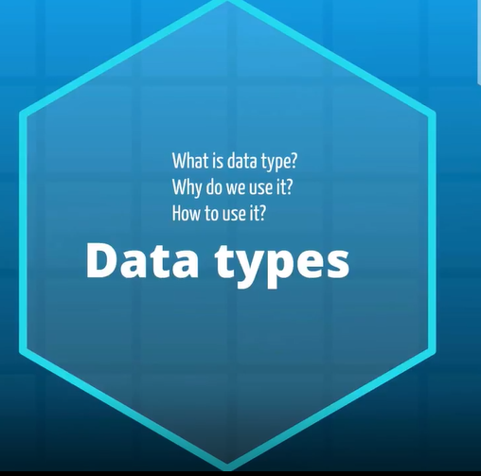  
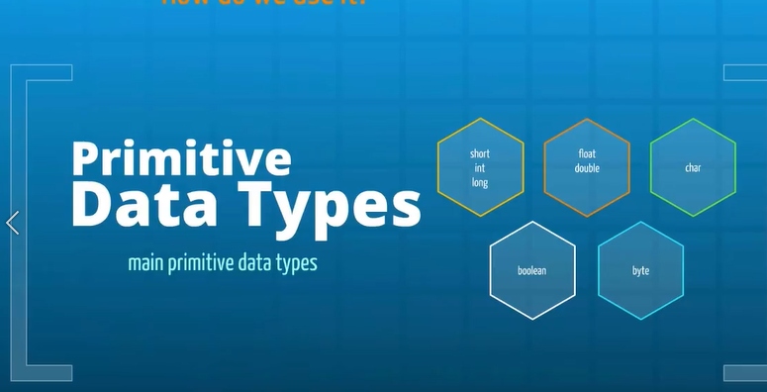

* Primitive data types – gonar jonno use hoy

New project nibo

* Project er nam boro hat er diye shuru korbo



* Short int long eder bole purno sonngkha
* Math korar somoy x er moddhe je kono kichu save kortam
* Short chotopurno songkha, int tar cheye ektu boro purno songkha, long tar cheye boro purno sonkha
* 16 bit er int holo short

Variable declare kora  
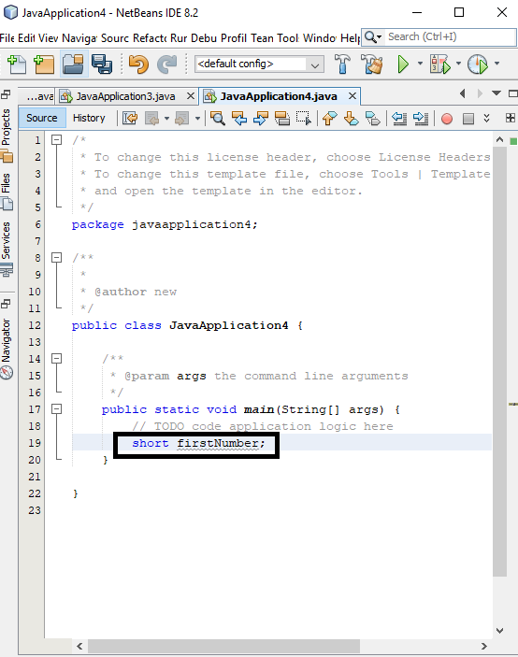

* Int besi bebohar kora hoy
* Int=32 bit= 2 to the power 2 minus1 , holo etar limit
* Long hocche 64 bit

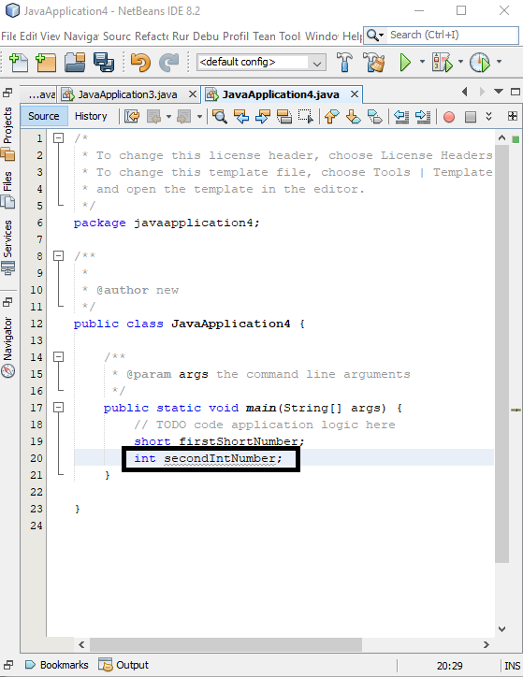

*variable e kono gap deya jabe na

Example: firstIntNumber

* Variable er name r first e 124dye shuru kora jabe na

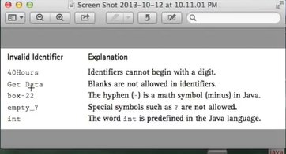

* Variable er nam eccha korlei egulo deya jabe na, karon egulo javar nijosso word
* Descreptive nam deya uchit

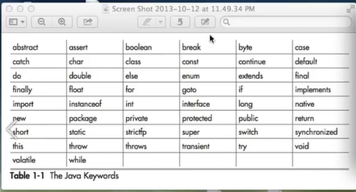

Value jevabe deya lage:

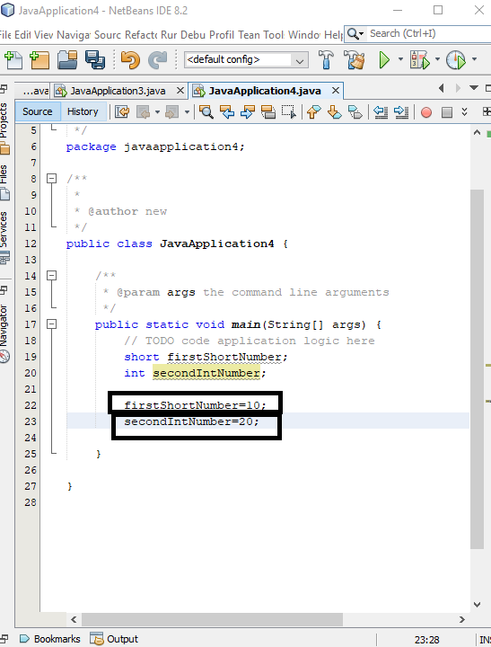  
ekhon Jodi boli firstshortnumber ta k show koraite,

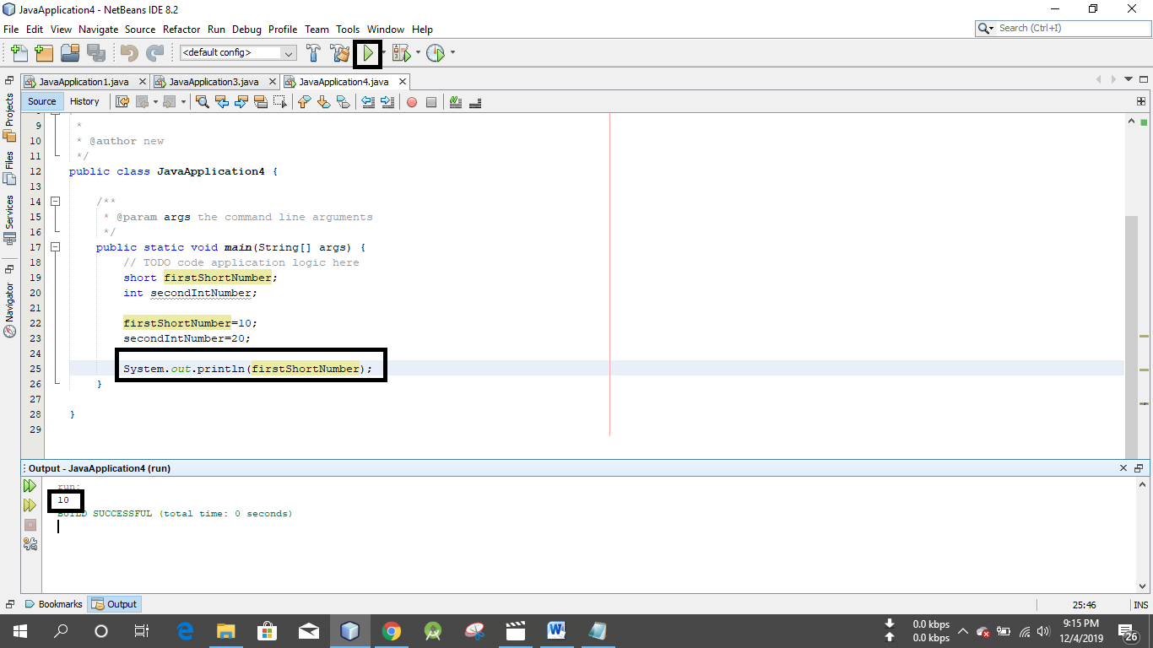  
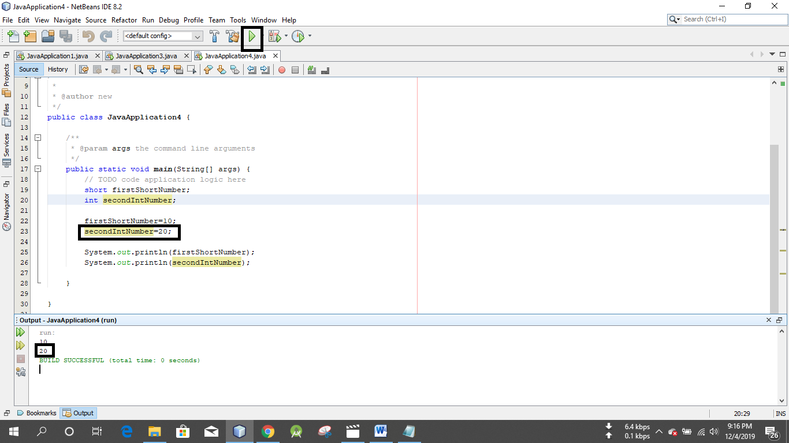

Arekta variable banabo, ek bare value declare and assign korar niyom

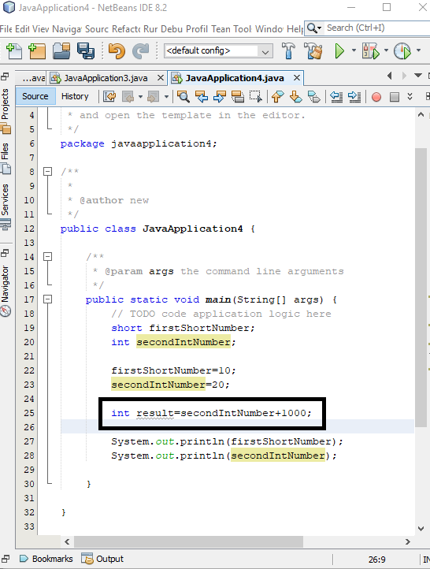

* Int purno songkha jehetu, eta diye vognangso represent kora jabe na
* 10/3=3. 33 ase, kintu int e thakle dosomik er porer man ta r ashen a

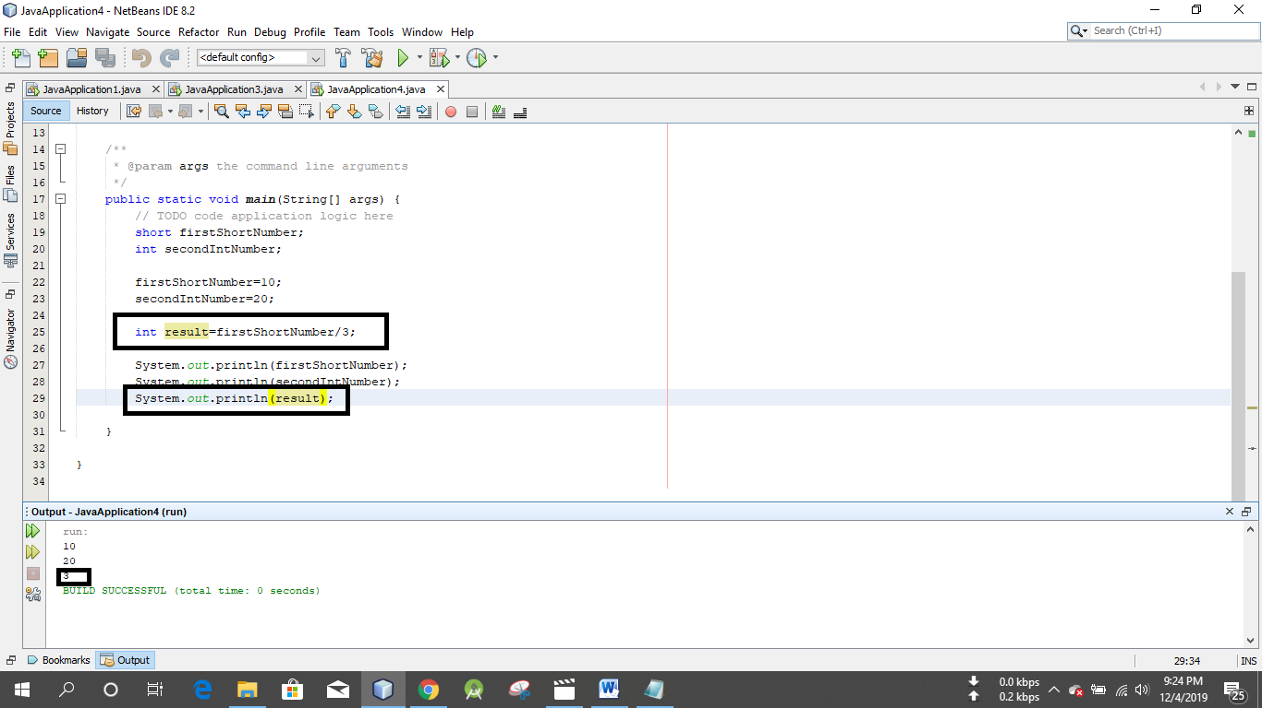

* Float dosomiker porer sonkha
* Float hocche single precition, 32 bit
* Double hocche double precition, 64 bit
* Dosomiker pore jokhon save kore pare, normal purno sonkha o se save korte pare

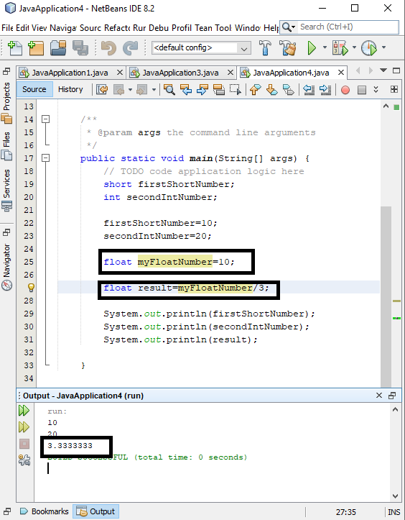

*memory save korar jonno long er cheye int use kora better, long jkhn dorkar hobe tokhon e use korbo,naile int diyei kaj chalabo

Ekhon dekhbo char ki:

* A b c d egulo holo character
* Char sobsomoy ekta word save kore
* Char likhar somoy ‘ ’ er vetor likhbo
* Java case sensitive, capital A & small a , o alada vabe dekhbe

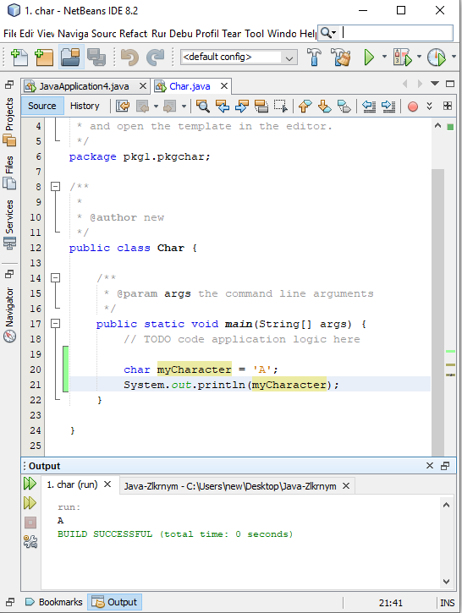

* ‘AB’ eksathe dile seta nibe na

Boolean:

* Duita value save korte pare, true/false
* Jodi ei ghotona ta sotti hoy tahole ei kaj korbe, r Jodi mittha hoy tahole onno kaj korbe

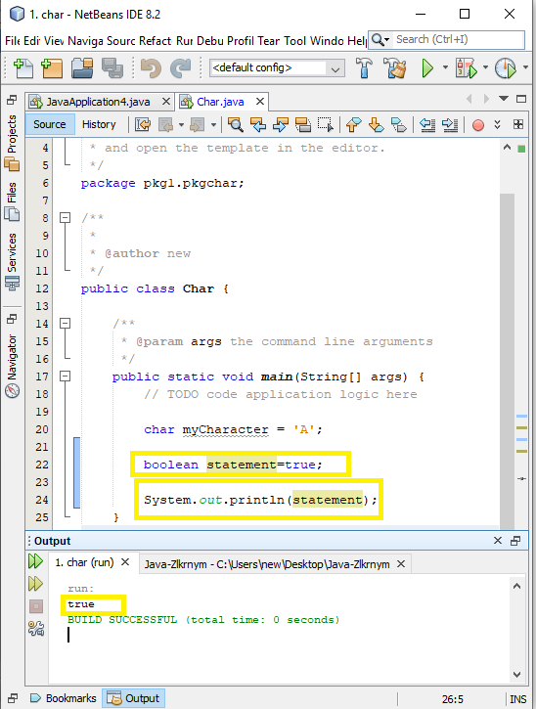

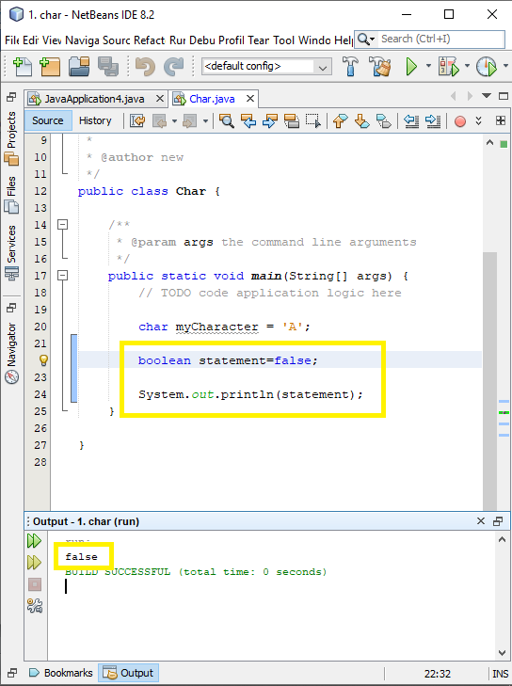

* 0 mane nai, 1 mane thik

Byte: 8 bit er data save kore